Aim: To deploy a Mini E-Commerce Progressive Web Application (PWA) on an SSL-enabled static hosting platform and make it accessible over the internet.

Theory:

Q1. What is deployment in web applications?
Deployment is the process of transferring a web application from a local development environment to a production server where it becomes accessible to end-users over the internet.

Q2. What is static hosting?
Static hosting means serving files that don’t change dynamically per request — typically HTML, CSS, JavaScript, images, fonts, and other media. Unlike dynamic hosting (e.g., PHP, Node.js, Python backends), there’s no server-side processing or database querying when a user requests a page.

Q3. Why is HTTPS required for PWAs?
Service Workers can intercept network requests, so HTTPS prevents tampering and ensures secure communication. Required for installing the PWA.

Q4. Name any three platforms used for deploying PWAs.
- Vercel
- Netlify
- Firebase Hosting
- Github Pages
- AWS S3
- Google Cloud Storage
- Azure Static Web Apps
- Gitlab Pages

Q5. What is the role of Service Worker after deployment?
It caches assets, enables offline access, intercepts network requests, and handles background sync or push notifications.

Q6. What are the advantages of deploying a PWA online?
- Installable on devices
- Works offline
- Fast loading (cached assets)
- No app store needed
- Lower data usage and improved performance

Q7. To deploy a Mini E-Commerce PWA and observe its behavior.

Repository Created and code pushed.
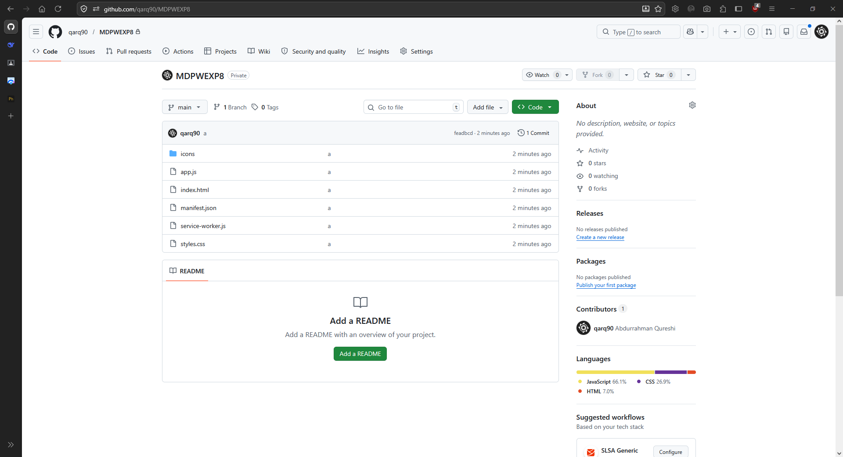

Setting ‘main’ branch as the source branch.
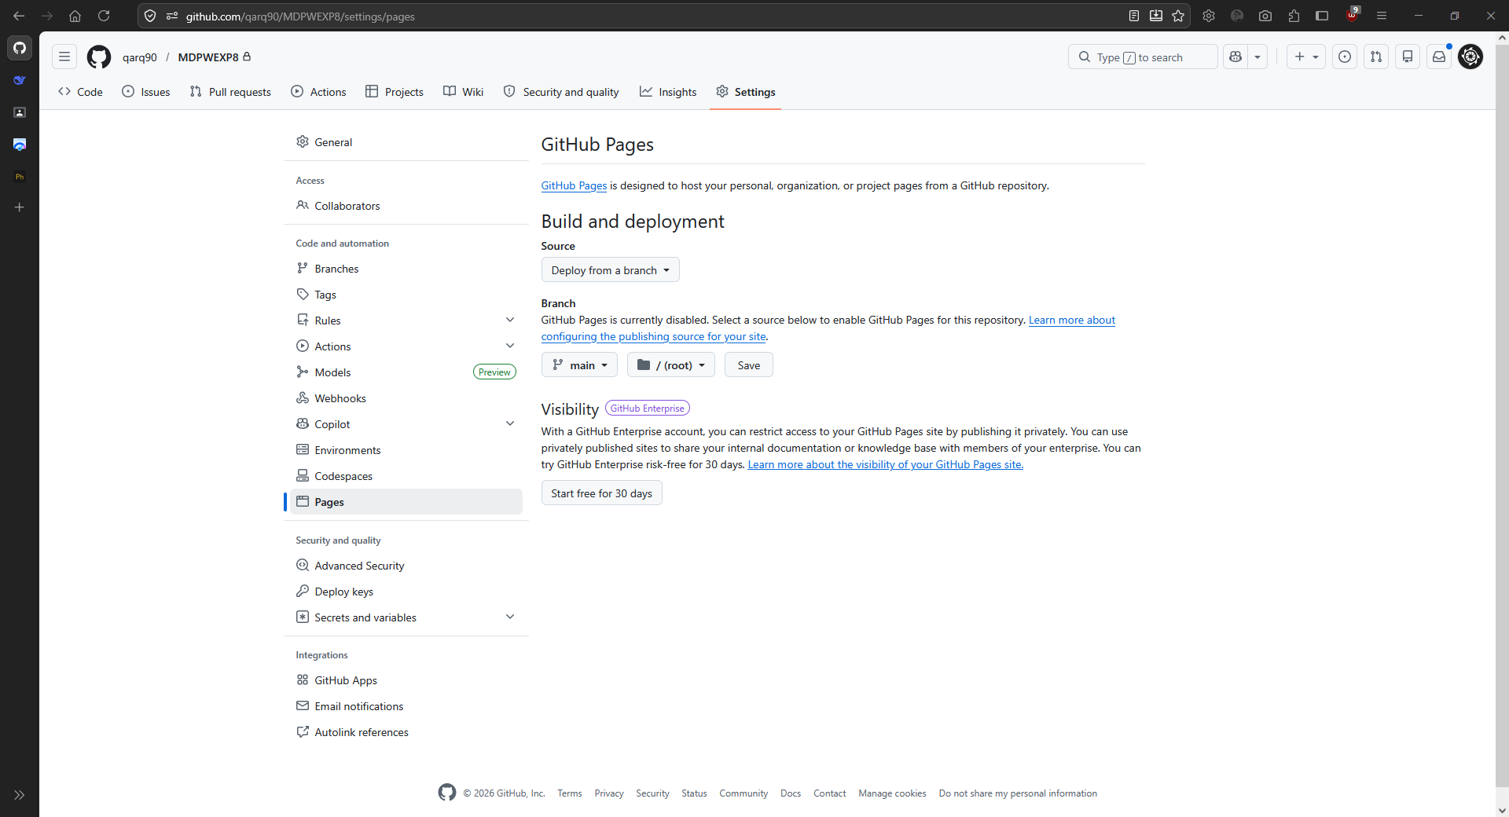

Deployed Link: https://qarq90.github.io/MDPWEXP8/



Conclusion
Successfully deployed a Mini E-Commerce Progressive Web Application (PWA) on an SSL-enabled static hosting platform and make it accessible over the internet.

